**Design**

**Discipline Document**

**I-3 Analysis and Software Design**

**Project: HHS Term Planning**

**Date: 28-04-2014**

**Owner:****Djastin van Damme, Tim van der Meer, Arif Munaf**

**Version: 1.0**

**Document History**

**Revision History**

|  |  |  |
| --- | --- | --- |
| **Version** | **Revision date** | **Summary of changes** |
| 0.1 | 28-03-2014 | Added data model and architectural structure |
| 1.0 | 9-4-2014 | Finalized document |

**Distribution**

This document is intended for:

|  |  |  |  |
| --- | --- | --- | --- |
| **Name** | **Function** | **Date of issue** | **Version** |
| Lustenhouwer, Wim | Project manager | 9-4-2014 | 1.0 |
| van Damme, Djastin | Co-project manager | 9-4-2014 | 1.0 |
| Indian Coding Company |  | 9-4-2014 | 1.0 |

Table of Contents

1. Introduction 4

2. Architectural structure 5

3. Detailed design model 6

3.1 Subsystems 6

3.2 Class Diagram 7

3.3 Sequence diagrams 8

3.4 GUI Designs 9

4. Data model 12

1. Introduction

This document contains the general architectural structure of the system and its subsystems. One of these subsystems is designed in detail in this document.

2. Architectural structure

The following diagram depicts the most global view of the system's architecture. See the appended documents for a larger version.

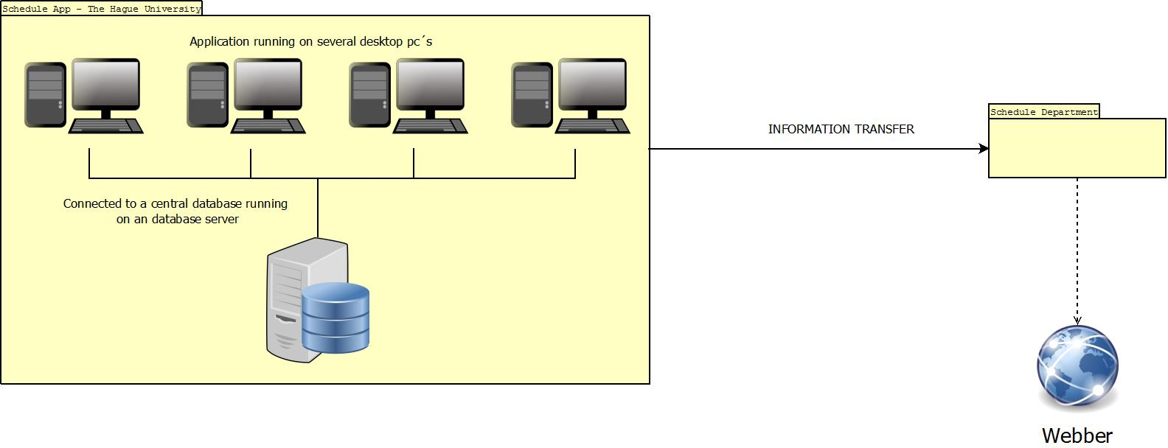

The next diagram shows the baseline architectural structure of the system, based on the MVC design pattern. How this relates to our subsystems will be explained in chapter 3.

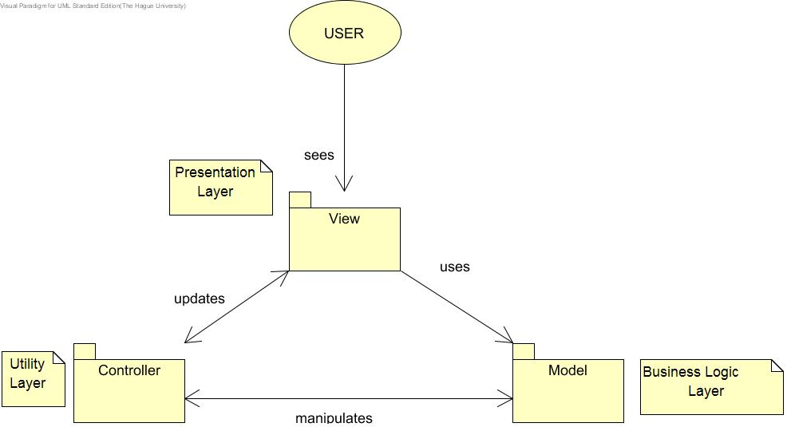

3. Detailed design model

3.1 Subsystems

The following diagram specifies the subsystems that make up the complete system. Each of the subsystems has its own model, controller and view elements embedded. How this works exactly will be illustrated in the class diagram.

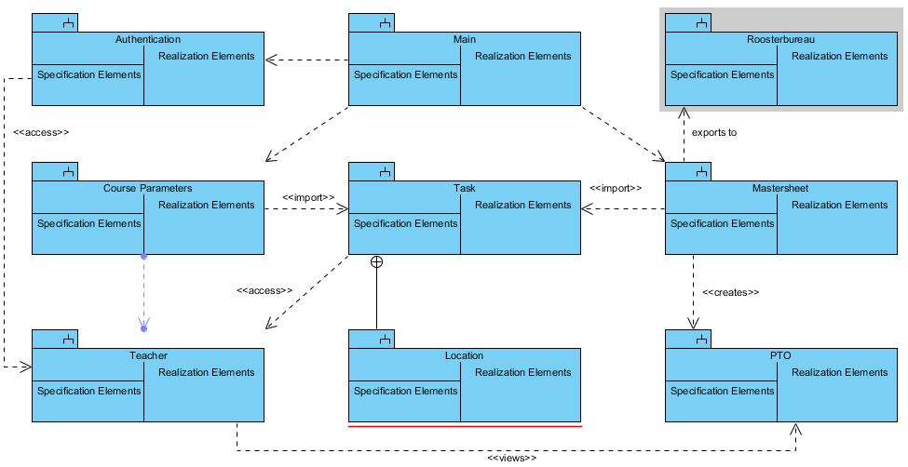

The subsystems Task (and by extension, Location), Teacher and a part of Authentication will be designed in detail in the class, sequence and state diagrams. We have chosen these systems because they are part of the essence of the program and we therefore feel that designing them would give a meaningful view into the inner workings of the system.

3.2 Class Diagram

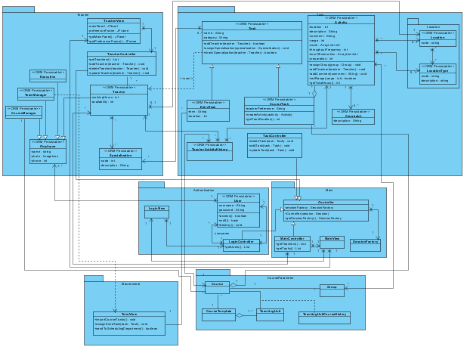

For an understandable version of the class diagram, check one of the appended documents.

3.3 Sequence diagrams

This diagram shows the process of assigning a teacher to a task. See the appended documents for a large version.

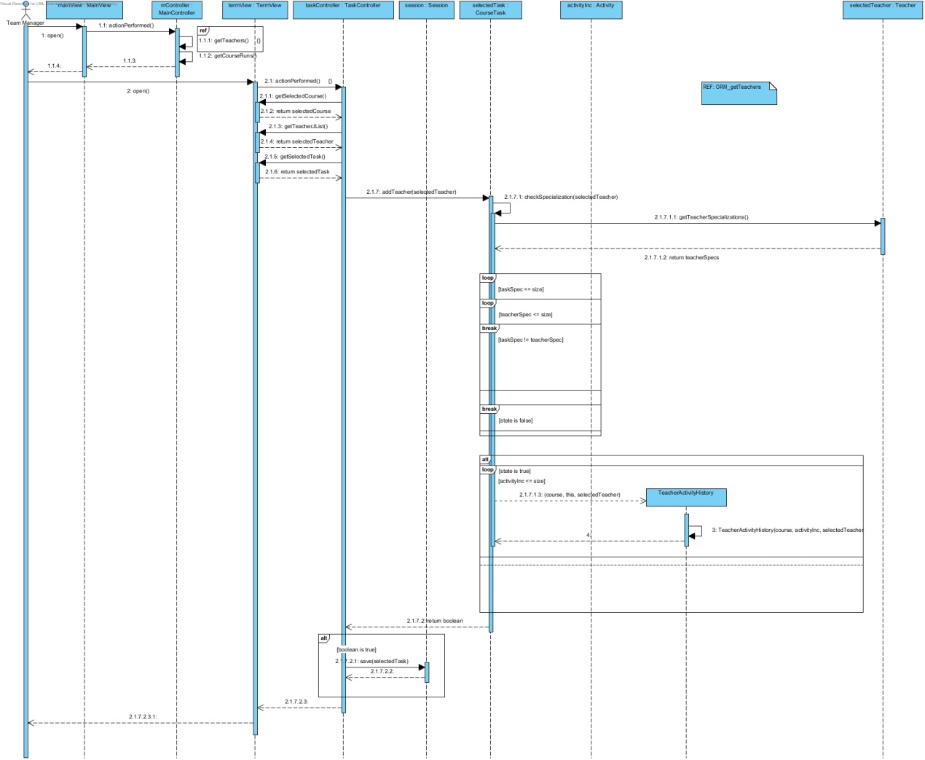

This diagram illustrates the way teacher entities are loaded into a list by the ORM system. A larger version is available in the appendix.

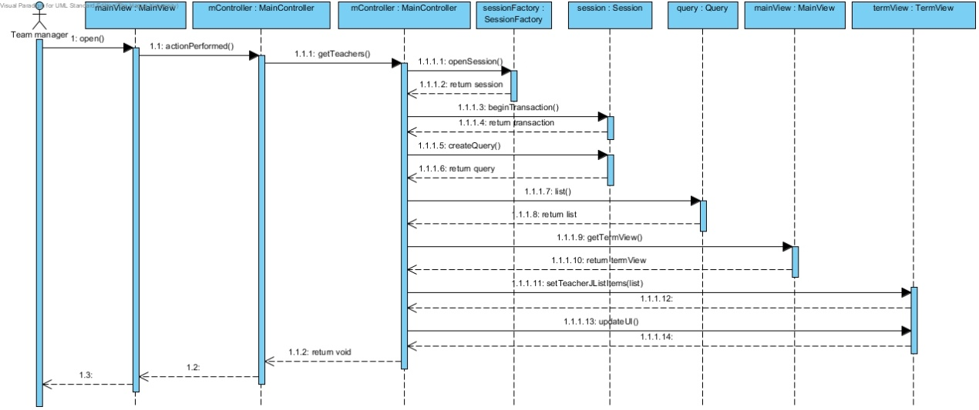

3.4 GUI Designs

*Team Manager, Specialisation Management Screen #1*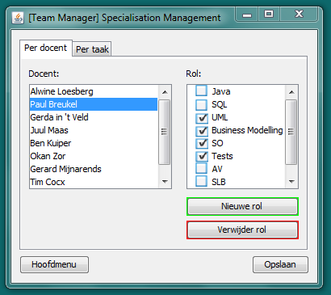

*Team Manager, Specialisation Management Screen #2*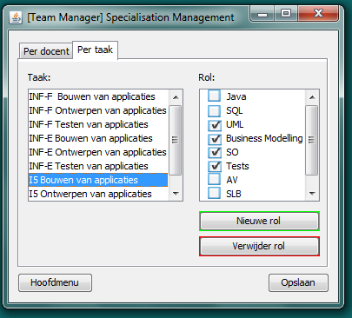

*Team Manager, Teacher Details Screen*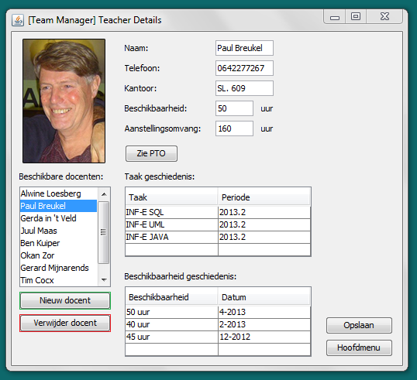

*Team Manager, Term View*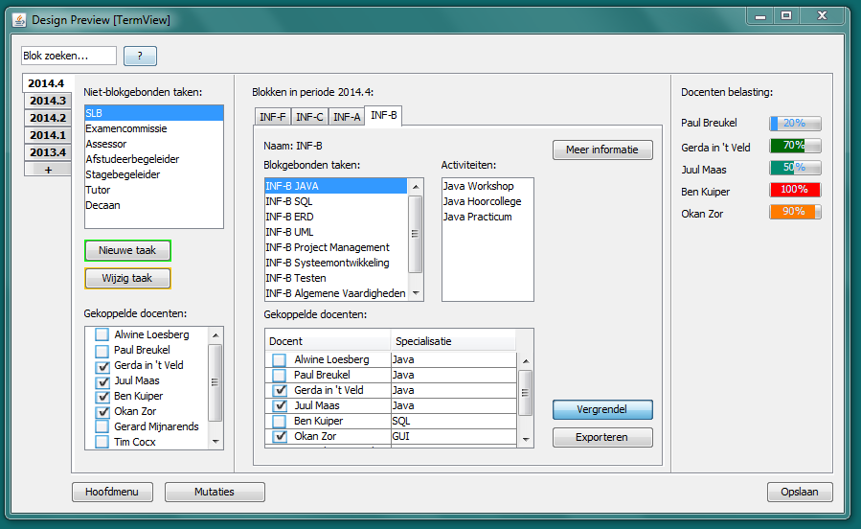

*Course Manager, Task Management Screen*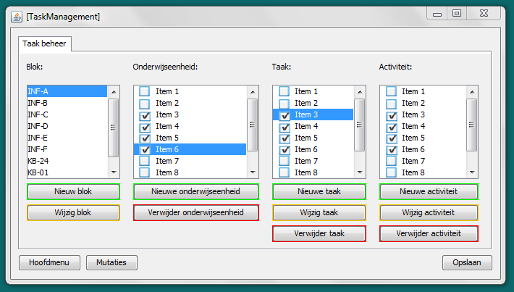

4. Data model

Check the appended documents for a larger version.

